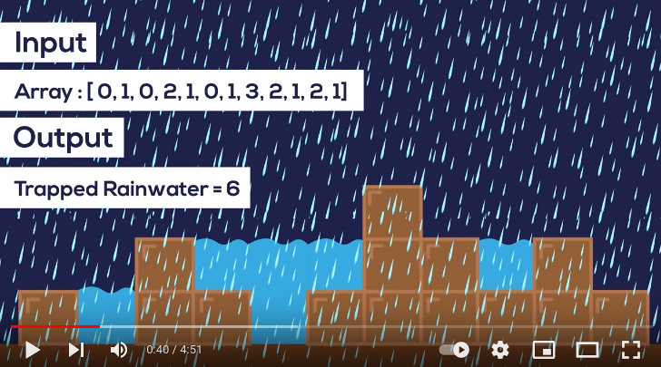
Rain water harvetng problem using Stack

First using Brute force:

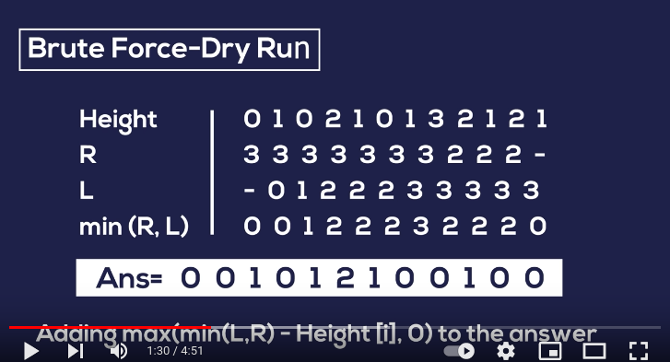

Now using stack:
first we find the baar which is lesser than currect bar, then find differnce and min height between two.

// rain water harvesting
#include<bits/stdc++.h>
using namespace std;

int total_area(vector<int> a){
int n= a.size(), ans=0;
stack<int> st;
for(int i=0 ;i<n ; i++){
while(!st.empty() and a[st.top()]< a[i]){
int cur=st.top();
st.pop();
if(st.empty()){
break;
}
int diff=0; // for length of container
diff= i-st.top()-1;
ans += (min(a[st.top()],a[i]) - a[cur]) * diff;
}
st.push(i);

}
return ans;
}

int main(){
vector<int > a={0,1,0,2,1,0,1,3,2,1,2,1};
cout<<total_area(a);

}

